PL/SQL Assignment Report
Name: Aditya Dixit
Email: optional1618@gmail.com

Exercise 3: Stored Procedures

Scenario 1
Scenario:
The bank needs to process monthly interest for all savings accounts.
Question:
Write a stored procedure ProcessMonthlyInterest that calculates and updates the balance of all savings accounts by applying an interest rate of 1% to the current balance.

PL/SQL Code
CREATE OR REPLACE PROCEDURE ProcessMonthlyInterest
IS
BEGIN
UPDATE Accounts
SET Balance = Balance + (Balance * 0.01)
WHERE AccountType = 'Savings';
COMMIT;
DBMS_OUTPUT.PUT_LINE('Monthly interest processed successfully.');
END;
/
BEGIN
ProcessMonthlyInterest;
END;
/
SELECT * FROM Accounts;

Screenshot 1 - DBMS Output

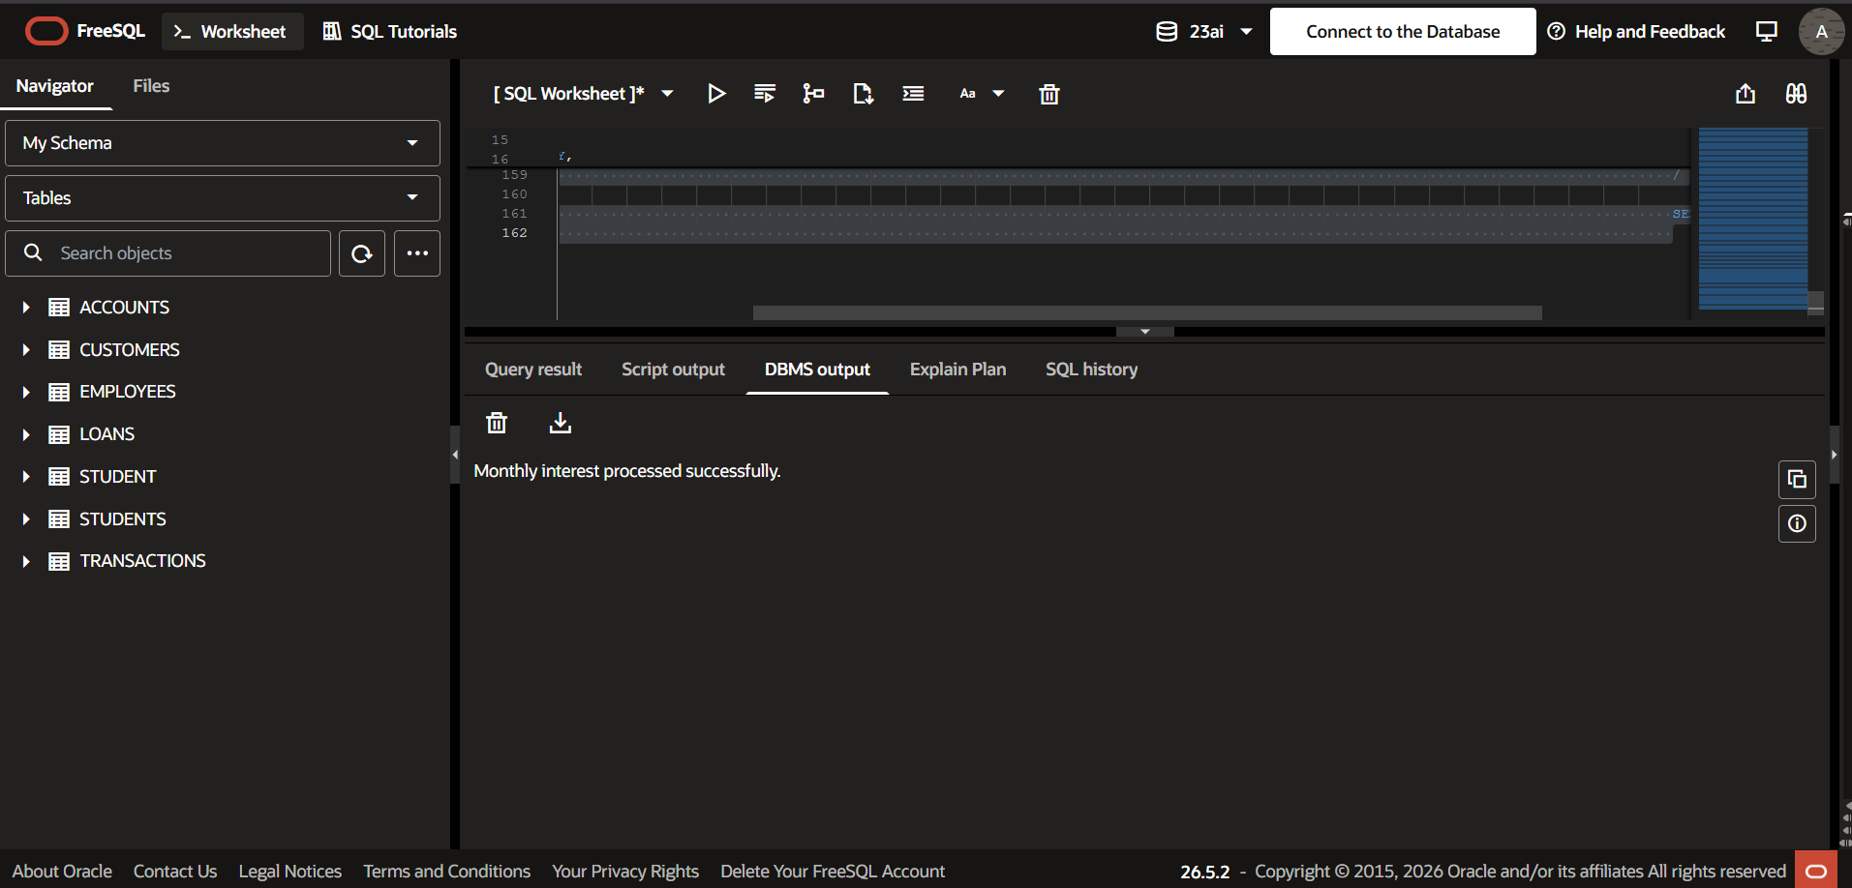Screenshot 2 - Verification Query Output
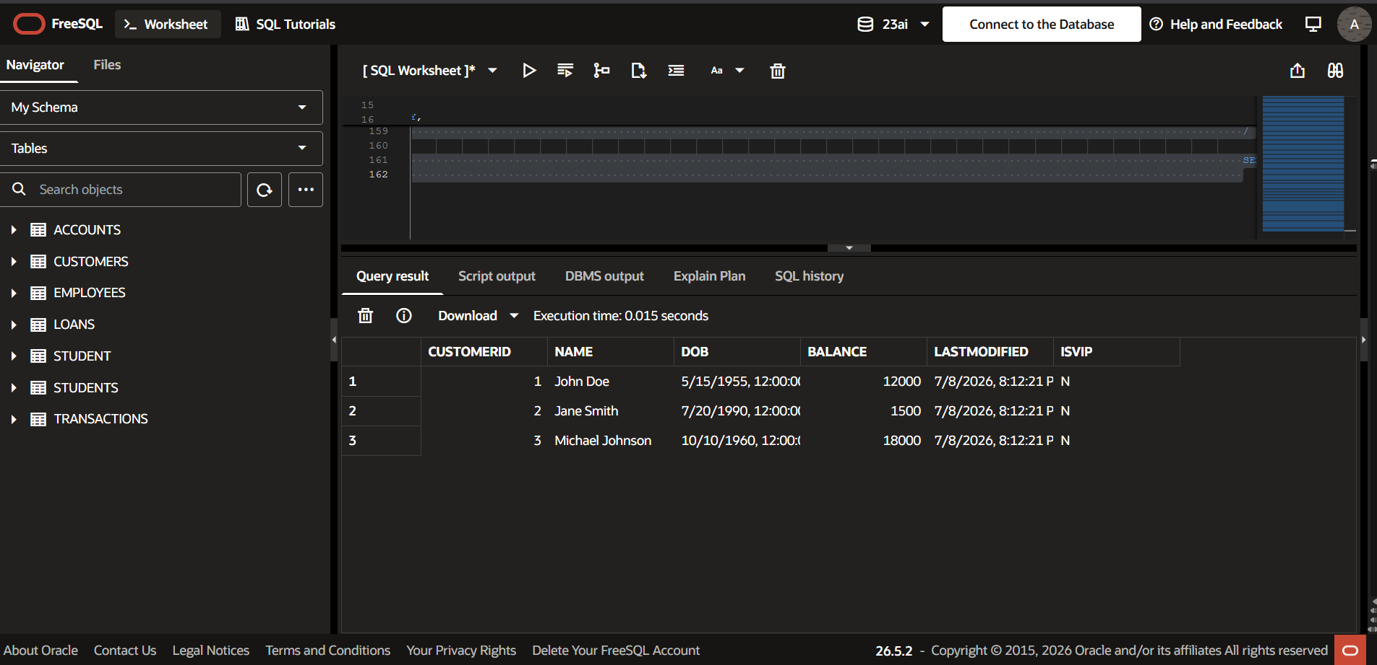

Scenario 2
Scenario:
The bank wants to implement a bonus scheme for employees based on their performance.
Question:
Write a stored procedure UpdateEmployeeBonus that updates the salary of employees in a given department by adding a bonus percentage passed as a parameter.

PL/SQL Code
CREATE OR REPLACE PROCEDURE UpdateEmployeeBonus(
p_department IN VARCHAR2,
p_bonus IN NUMBER
)
IS
BEGIN
UPDATE Employees
SET Salary = Salary + (Salary * p_bonus/100)
WHERE Department = p_department;
COMMIT;
DBMS_OUTPUT.PUT_LINE('Bonus updated successfully.');
END;
/
BEGIN
UpdateEmployeeBonus('IT',10);
END;
/
SELECT * FROM Employees;

Screenshot 1 - DBMS Output

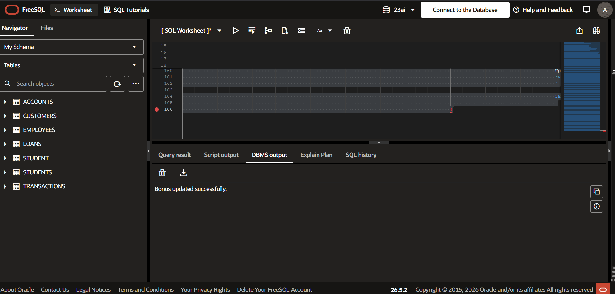Screenshot 2 - Verification Query Output
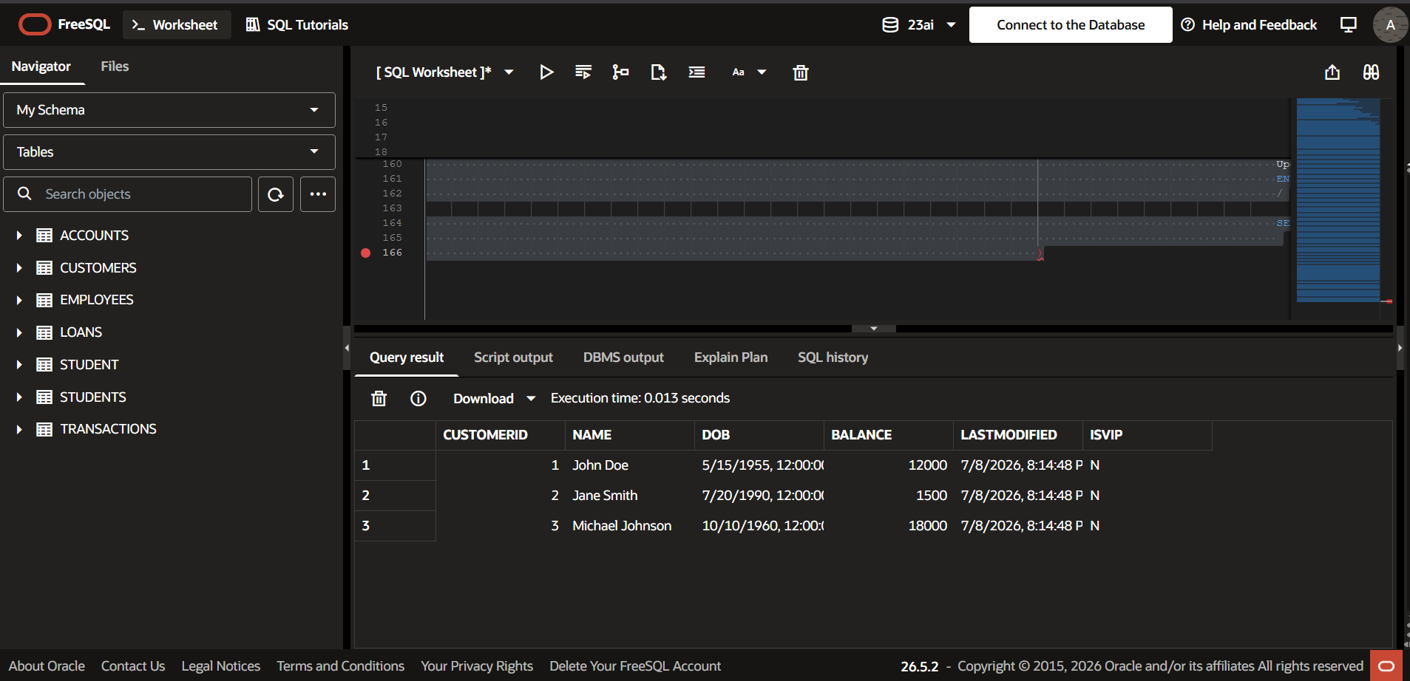

Scenario 3
Scenario:
Customers should be able to transfer funds between their accounts.
Question:
Write a stored procedure TransferFunds that transfers a specified amount from one account to another, checking that the source account has sufficient balance before making the transfer.

PL/SQL Code
CREATE OR REPLACE PROCEDURE TransferFunds(
p_fromAccount IN NUMBER,
p_toAccount IN NUMBER,
p_amount IN NUMBER
)
IS
v_balance NUMBER;
BEGIN
SELECT Balance
INTO v_balance
FROM Accounts
WHERE AccountID = p_fromAccount;
IF v_balance >= p_amount THEN
UPDATE Accounts
SET Balance = Balance - p_amount
WHERE AccountID = p_fromAccount;
UPDATE Accounts
SET Balance = Balance + p_amount
WHERE AccountID = p_toAccount;
COMMIT;
DBMS_OUTPUT.PUT_LINE('Fund transfer successful.');
ELSE
DBMS_OUTPUT.PUT_LINE('Insufficient Balance.');
END IF;
END;
/
BEGIN
TransferFunds(1,2,1000);
END;
/
SELECT * FROM Accounts;

Screenshot 1 - DBMS Output

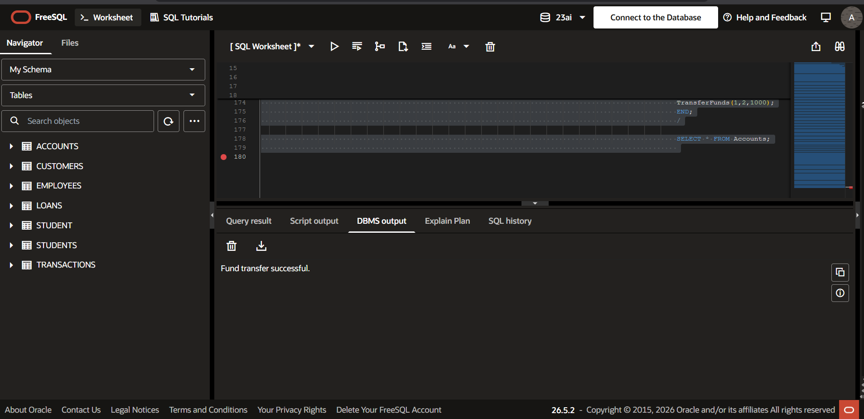Screenshot 2 - Verification Query Output


